

FURTHER MATHEMATICS
TRIAL EXAMINATION 1
SOLUTIONS
2008

Section A – answers Section B – answers

Core Module 1 Module 2 Module 3 Module 4 Module 5 Module 6
Number Geometry Graphs Business Networks Matrices
Patterns & & related &
Trig Relations Maths Decision

Maths
1. C 1. D 1. B 1. A 1. A 1. D 1. C
2. D 2. B 2. E 2. C 2. E 2. E 2. B
3. E 3. C 3. D 3. B 3. B 3. B 3. C
4. D 4. B 4. A 4. C 4. D 4. B 4. C
5. D 5. C 5. E 5. D 5. C 5. A 5. D
6. C 6. E 6. C 6. E 6. D 6. C 6. E
7. A 7. C 7. A 7. D 7. B 7. B 7. A
8. B 8. A 8. D 8. B 8. E 8. C 8. B
9. B 9. C 9. C 9. E 9. D 9. E 9. E
10. C
11. D
12. D
13. C

Core - solutions

Question 1

The number of students who weigh more than 32kg is .
The answer is C.

Question 2

The percentage of students who weigh between 26 and 30kg is 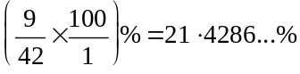.
The closest answer is 21%.
The answer is D.

Question 3

The variable “season”, is a categorical variable.
The variable “retail sales” is a numerical variable.
The answer is E.

Question 4

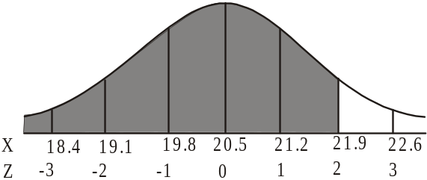
So 21.9 is two standard deviations above
the mean.
We know that 95% of lengths lie between
2 standard deviations either side of the mean
therefore 5% lies above 2 standard deviations
above the mean and below 2 standard
deviations below the mean.
Because of the symmetry of the normal curve,
2.5% of lengths therefore lie above 2 standard
deviations above the mean so 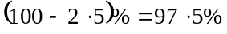
are less than 2 standard deviations above the mean.
The answer is D.

Question 5

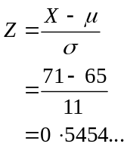
The closest answer is 0.55.
The answer is D.

Question 6

There are 28 weights.
Since the stemplot is ordered, we can “count in” from either end. The 14th weight is 71kg and the 15th is 71kg.
Therefore the median weight is 71kg.
The answer is C.

Question 7

The distribution of weights of both clubs is symmetrical.
The centre of the weights of Club X are less than the centre of the weights of Club Y so the weights of Club X are generally less than those of Club Y. The spread of weights of Club X is less than that of Club Y and hence the weight of Club X members is less variable than those of Club Y.
The answer is A.

Question 8

The least squares regression line is a linear equation.
For every 1cm increase in length, the weight is increased by 53.2g.
For example let’s say
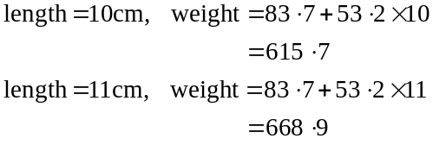
which is obviously a difference of 53.2 and so on.
The answer is B.

Question 9

The residual value = actual value – predicted value.
For , the residual is
For , the residual is 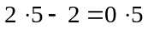
For , the residual is 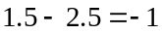
For , the residual is 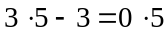
For , the residual is 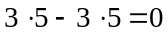
Only graph B shows these residual values.
The answer is B.

Question 10

Use a calculator to find the least squares regression line of the transformed data. The two lists you use to find this regression line should be and y.
The regression line is 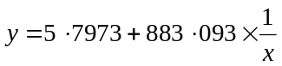.
The answer is C.

Question 11

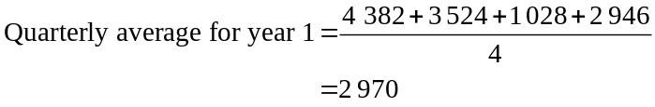
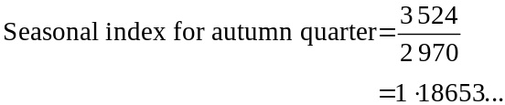
The closest answer is 1.19.
The answer is D.

Question 12

Season | No. of visitors | 2-moving mean | 2-moving mean with centring
Summer | 4 382
 |  | 3 953
Autumn | 3 524 |  | 3 114.5
 |  | 2 276
Winter | 1 028

The answer is D.

Question 13

Summer of year 1 corresponds to season number 1.
Autumn of year 1 corresponds to season number 2.

Following this pattern,
Winter of year 1 corresponds to season number 3.
Winter of year 2 corresponds to season number 7.
Winter of year 3 corresponds to season number 11.
Winter of year 4 corresponds to season number 15.
Winter of year 5 corresponds to season number 19.
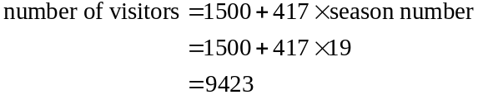
The answer is C.

SECTION B

Module 1: Number patterns

Question 1

If a sequence is geometric it has a common ratio. Only option D has this.
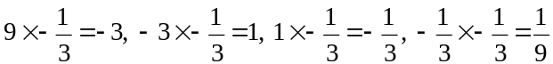
The answer is D.

Question 2

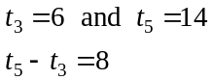
The difference between successive terms is therefore .
So 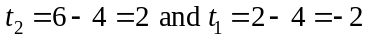
The answer is B.

Question 3

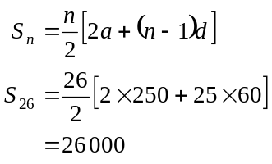
The answer is C.

Question 4

In 2004 there were 3 200 subscribers.
In 2005 there were subscribers.
In 2006 there were subscribers.
In 2007 there were subscribers.
The closest answer is 839
The answer is B.

Question 5

Each year the trout increase naturally by 38% of the previous year’s population.
This is represented by 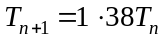.
However, 550 trout are sold at the end of each year.
So, 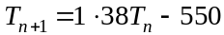
The answer is C.

Question 6

A difference equation with form 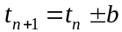 describes an arithmetic sequence.
A difference equation with form 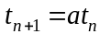 describes a geometric sequence.
The difference equation 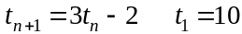 describes neither an arithmetic nor a geometric sequence.
The answer is E.

Question 7

The sequence is not arithmetic so option A is incorrect.
The sequence is not geometric so option B is incorrect.
Option D generates the sequence 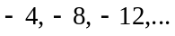 and so is incorrect.
Option E generates the sequence 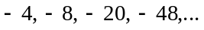and so is incorrect.
Option C is correct.
The answer is C.

Question 8

The first term is negative (i.e. below the n axis) so .
The common ratio must also be negative since the second term is positive, the third term is negative, the fourth term is positive and so on. To produce this pattern, .
The answer is A.

Question 9

The sequence is geometric with .
We are looking for the sum of an infinite geometric sequence.
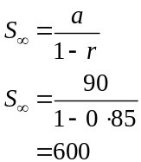
The answer is C.
Module 2: Geometry and trigonometry

Question 1

In relation to , we have the opposite side and the hypotenuse.
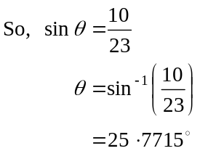
The closest answer is 26.
The answer is B.

Question 2

We have two angles, one side and need to find a second side so we use the sine rule.
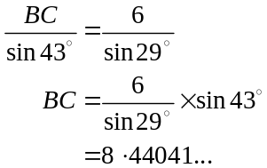
The closest answer is 8.4m.
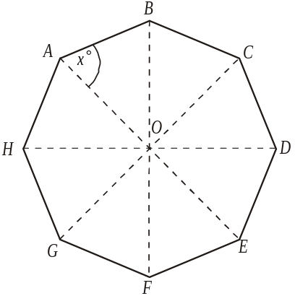

The answer is E.

Question 3

Method 1
In the regular octagon shown,
the angles at the centre are equal to 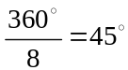.
Because the octagon is regular, etc.
So is isosceles.

So in the triangle shown, 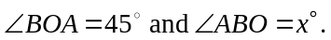
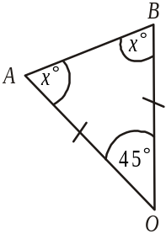
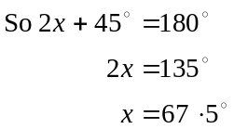

The answer is D.

Method 2
The sum of the interior angles of a regular polygon 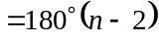
The sum of the interior angles of a regular octagon is therefore 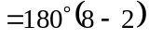
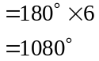
So each of the 8 interior angles 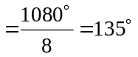
So 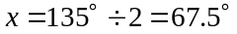.
The answer is D.

Question 4

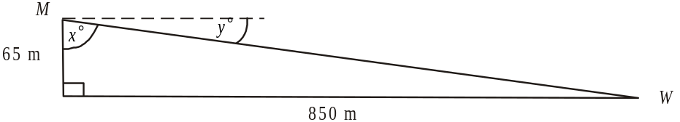

The angle of depression required is 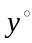.
We need to find angle 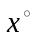 first.
In the right-angled triangle,
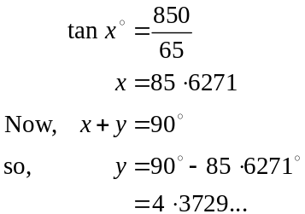
The required angle of depression is closest to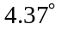.
The answer is A.

Question 5

The shape of the tins is similar.
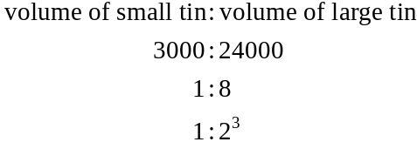
So the ratio of the sidelengths of the small tin to the sidelengths of the large tin is 1:2.
The height of the small tin is .
The answer is E.

Question 6

Using the contour lines we see that B is 30m higher than A.
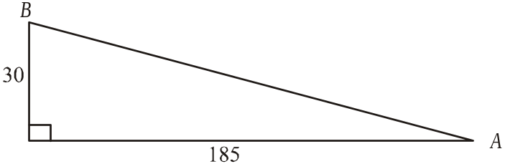

So, using Pythagoras’ Theorem.
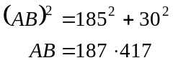
The closest answer is 187.
The answer is C.

Question 7

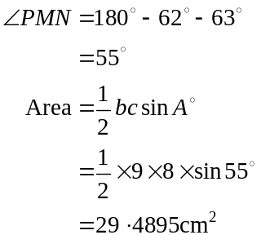
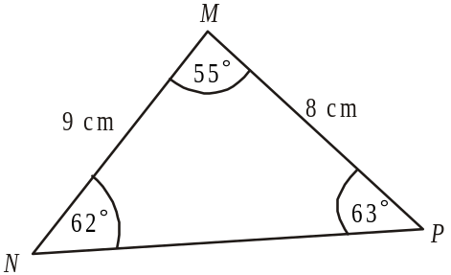
The closest answer is 29.5.
The answer is A.

Question 8
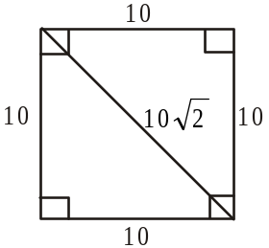

In the base of the pyramid the length of the diagonal
is 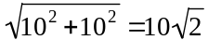.

In the triangle with sidelengths running from the top
of the pyramid down a slant side, into the centre
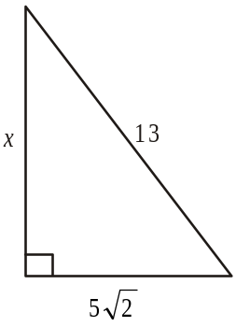
of the base and up to the top again,
we have
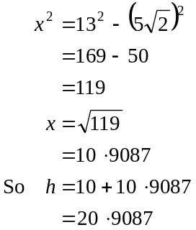
The answer is D.

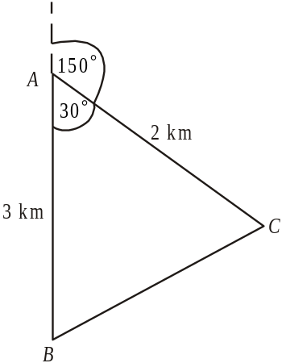

Question 9

Draw a diagram.

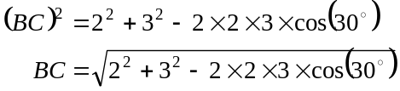
The answer is C.

Module 3: Graphs and relations

Question 1

The equation of the vertical line is since each point on the line has an x-coordinate of 3.
The answer is A.

Question 2

Since 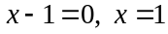.
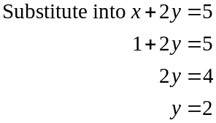
Both lines pass through the point 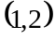.
The answer is C.

Question 3

The graph of 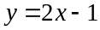 has a gradient of 2 so it slopes up to the right (positive gradient). We can eliminate options C and E. It has a y-intercept of – 1 so we can eliminate option D.
In option A, the gradient is . In option B, the gradient is 2; that is over a given section of the graph it “rises” 2 units and “runs” 1 unit. So between the points 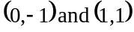 it rises 2 and “runs” 1.
The answer is B.

Question 4

Option A costs 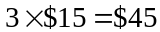.
Option B costs 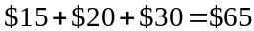.
Option C costs 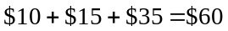.
Option D costs 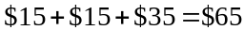
Option E costs 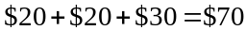
The answer is C.

Question 5

From the graph, the corner points occur at 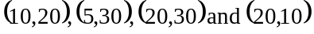. The maximum total of the x and y coordinates is 50.
The answer is D.

Question 6

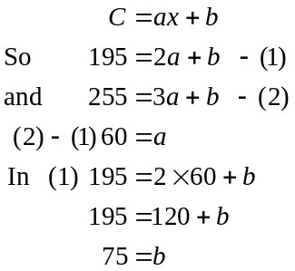
The fixed cost of a house call is $75.
The answer is E.

Question 7

Jane’s revenue after selling 48 cards was 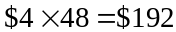. She broke even at this point so her costs were also $192.
Her fixed costs were $72 so it cost $192 - $72 = $120 to produce 48 cards; that is, it cost 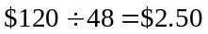 per card.
The answer is D.

Question 8

The relationship in the graph shown is given by 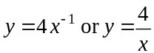.
The point 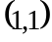 does not satisfy this equation since .
The point 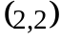 does satisfy this equation since 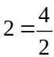.
The points 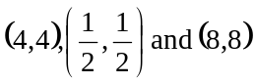 do not satisfy this equation.
The answer is B.

Question 9

Method 1 – graphically

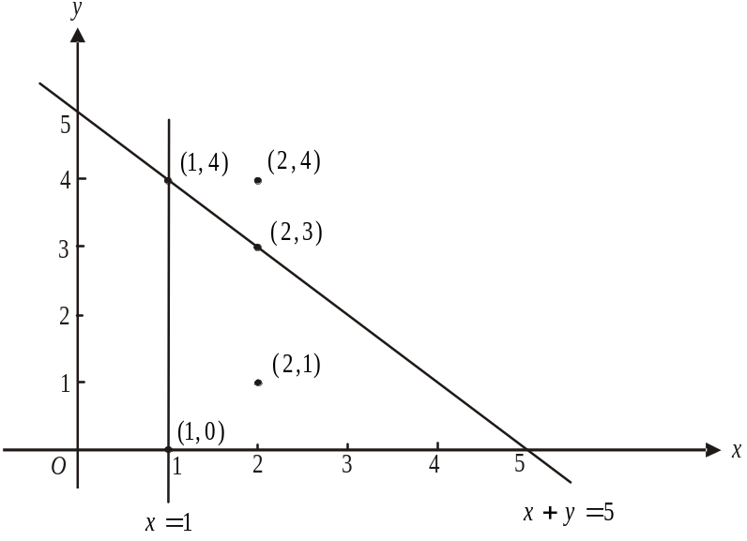

The points 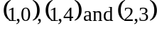 lie on the border which is included. The point 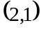 lies inside the feasible region. The point 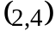 lies outside the region.
The answer is E.

Method 2 – algebraically

Check each point.

For .
For .
For .
For .
For .

The point 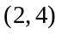 does not satisfy the inequation 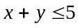 and therefore does not lie in the feasible region.
The answer is E.
Module 4: Business-related mathematics

Question 1

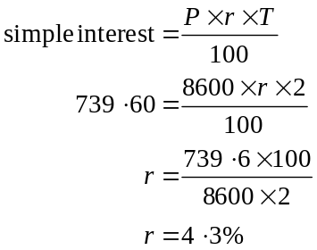
The answer is A.

Question 2

The balance on 15 June was .
The balance on 7 June was 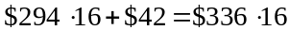.
The amount that Oliver withdrew on 15 June was 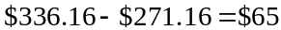.
The answer is E.

Question 3

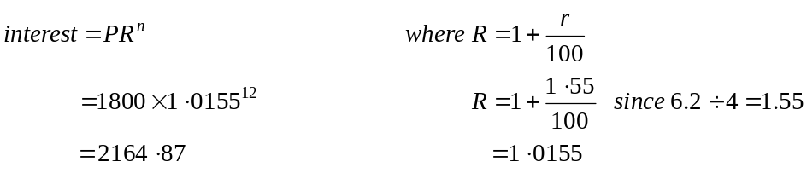
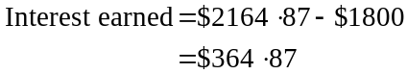
The answer is B.

Question 4

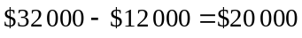
The machine will have depreciated by $20 000 by the time it is replaced.
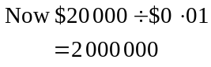
The machine will have helped produce 2 000 000 cans.
The answer is D.

Question 5

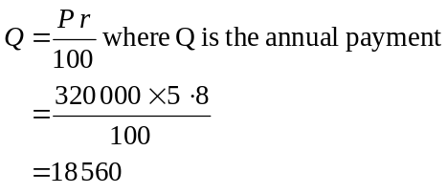
Monica receives $18 560 annually from the perpetuity which gives a monthly pension of
$1 546.67. The closest answer is $1 547.
The answer is C.

Question 6

Using TVM solver we have
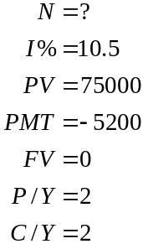

six month periods.
So Joe fully repays the loan after years (to 1 decimal place).
The answer is D.

Question 7

Using TVM solver we have
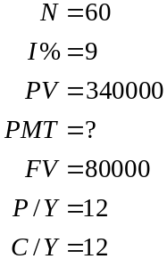
Their monthly payment is $8 118.51.
The answer is B.

Question 8

In total Tim will pay
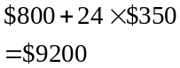
This represents 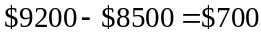 in interest.
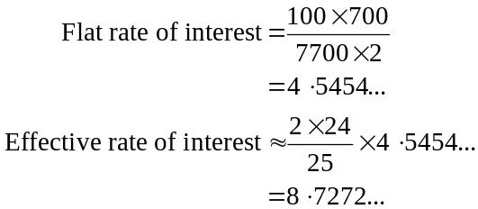
The closest answer is 8.73%.
The answer is E.

Question 9

Using TVM solver, for the first two years we have
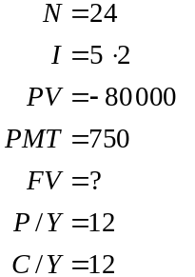
So after two years the annuity is worth $69 821.93.

For the remaining term of the annuity,
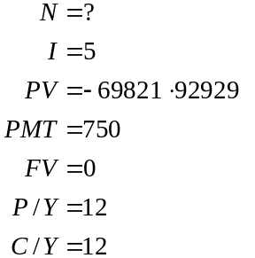
In total the term of the annuity is months.
The answer is D.

Module 5: Network and decision mathematics

Question 1

A connected graph is a graph where there is a path between each pair of vertices. Only Option D shows a connected graph because each point can be reached by each of the other points.
The answer is D.

Question 2

There is 1 path between A and B.
There are 2 paths between B and D.
Again there are 2 paths between D and B.
There is 1 path from C back to itself. The total is 6.
The answer is E.

Question 3

Because the graph is connected and planar we can use Euler’s formula 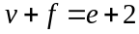.
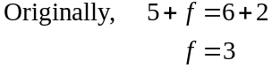
After the addition of 4 edges,
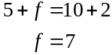
The number increased by 4.
The answer is B.

Question 4

Liam is only qualified for job B.
Hui is the only qualified person for job D.
Kaisha and Winnie are both qualified for jobs A and C so the two possible job allocations are

graduate | job
Kaisha | C
Winnie | A
Liam | B
Hui | D

graduate | job
Kaisha | A
Winnie | C
Liam | B
Hui | D

Option B provides the latter allocation.
The answer is B.

Question 5

If an Euler path exists then a graph will need to be connected (ruling out option D) and only two vertices will have odd degrees (i.e. the start and finish points).
All other vertices will have even degrees.
Only option A satisfies this criteria.
The answer is A.

Question 6

The one-step dominance matrix is
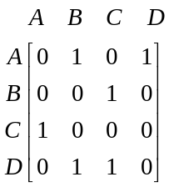
The two-step dominance matrix is
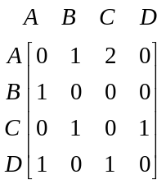
The one and two step dominance matrix is
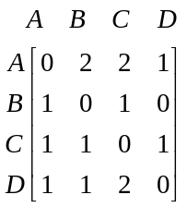

The answer is C.

Question 7

The immediate predecessors of activity E are A and C.
The answer is B.

Question 8

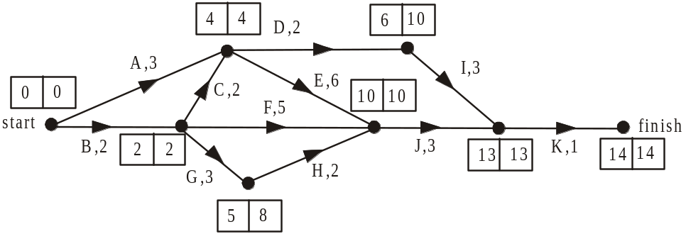

The critical path is B, C, E, J and K. By shortening the length of any of these activities the duration of the project will be reduced.
K could be reduced by up to1 day.
J could be reduced by up to 3 days.
E could be reduced by up to 3 days which puts F, G and H on the critical path as well.
C could be reduced by 1 day which puts A on the critical path.
B could be reduced by 1 day which puts A on the critical path.
The maximum possible reduction is 3 days.
The answer is C.

Question 9

Using only cuts A and B which have the respective capacities of 14 and 19, we know that the maximum flow cannot exceed 14 (minimum cut / maximum flow).
The answer is E.
Module 6: Matrices

Question 1

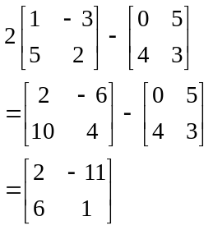
The answer is C.

Question 2

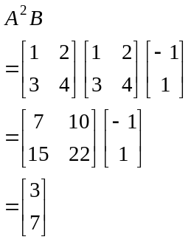
The answer is B.

Question 3

Options A and B are matrices.
Only option C shows the number of different sized skirts available at outlet B.
The answer is C.

Question 4

The matrix product in option A does not exist because the number of columns of the first matrix is 1 and the number of rows of the second matrix is 4.
The matrix product in option B gives a matrix whereas we want a matrix which gives us a total.
The matrix product in option C gives us a matrix which gives the total we require (eg. gives us the total paid to 17 year olds at the normal rate plus 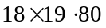 which gives the total paid to 17 year olds for penalty rates and so on).
The matrix product in option D gives us a matrix.
The matrix product in option E does not exist because the number of columns of the first matrix is 4 and the number of rows of the second matrix is 1.
The answer is C.

Question 5

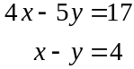

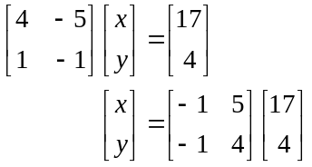
Note that the matrix 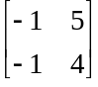 is the inverse matrix of 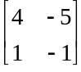.
The answer is D.

Question 6

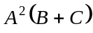 exists so matrices B and C have the same order as does the matrix . They each have 3 rows. So the number of columns of the matrix 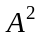 must be 3. Only square matrices can be squared so the order of matrix A is .
The answer is E.

Question 7

Now
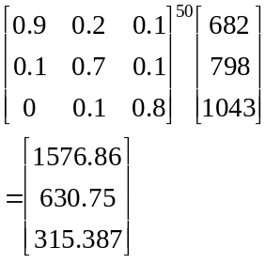
Also
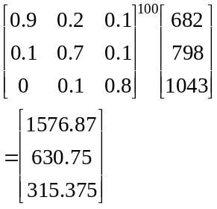
We have a steady state and the number of patrons at café B would be closest to 631.
The answer is A.

Question 8

Option A is not correct because the sum of the columns is greater than one.
Option B is correct because if Tootsie has been to Dr Wags this time there is zero chance of him going there next time and the chance of going to either of the other two vets is equally likely. Similarly if he has been to Dr. Claw this time then there is zero chance of him going to Dr. Claw next time but 0.5 probability of him going to Dr. Barker or Dr. Wags and so on.
The answer is B.

Question 9

If it’s raining in district A this hour the likelihood of it raining in district C next hour is 0.3.
If it’s raining in district C this hour the likelihood of it raining there again next hour is 0.5.
The likelihood of it raining in consecutive hours i.e. this hour and next hour in district B is 0.4.
The likelihood of it raining in consecutive hours in district C is 0.5.
The likelihood of it raining in consecutive hours in district A is 0.2.
The answer is E.

